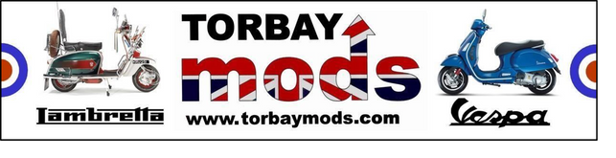


The majority of our communication is done via WhatsApp, if you would prefer to receive information in a different way, please advise the Membership Secretary Chris who will arrange this for you.
Full Name
Full Address
Telephone number
Email address
Type of scooter you own
Emergency contact name
Emergency contact number
MEMBERSHIP FORM

TORBAY MODS SCOOTER CLUB
Yes
No
Do you use WhatsApp (Mobile required)
Photos are commonly taken during ride outs, events and social gatherings.
Do you agree to the club posting photos of you on the club Facebook page / website for promotional and sharing purposes? Please note we are not responsible for anything posted by other members/general public.
Chairman: Mark Brooke
markbrooke1970@gmail.com
Mobile: 07790687080

Yes
No
Bank Details: Name: Torbay Mods Scooter Club Sort Code: 60-16-11 Account Number: 76653838

Full, £10.00 annually


More Info
Membership to Torbay Mods Scooter Club runs from 1st February - 31st January, it is not auto-renewed. By joining the club and submitting your details you agree for this information to be held by the committee for use of club only, it will not be shared outside of the club.

